End Project in Python
Presenter – Itay Zenkin
Class – י'2
Teacher – Golan Mor
Date – 10.06.2023



Table of Contents
3 Chapter 1
4 – 6 Chapter 2
7 – 22 Chapter 3
23 – 30 Chapter 4
31 Chapter 5

Chapter 1: Presentation of The Work Topic
I chose to do my work about the subject of cryptocurrencies, GPU, CPU and RAM Products prices throughout several years.
Research Question:
Does the rise of cryptocurrency prices affect products like GPU’s, CPU’s and RAM? And if so, are there specific parts in those products that are greatly affected by the rise of cryptocurrencies?
Central Assumptions:
My main assumption is that the rise of cryptocurrencies will affect the prices greatly and furthermore will extremely affect the products that have advanced parts because they can improve the efficiency of the mining for minable cryptocurrencies.
To check my assumptions, I will firstly check for specific rises in cryptocurrencies between the years and see if they match up with rises in the product’s average price. After confirming the assumption, I will check the prices for products with specific characteristics like higher number of cores in CPU products. To check that hypothesis I will do the same as the last one and check if they match up with the cryptocurrencies rise.

Chapter 2: Data Description
I am using 11 databases connected by specific key values. The databases are described and connected as follows:
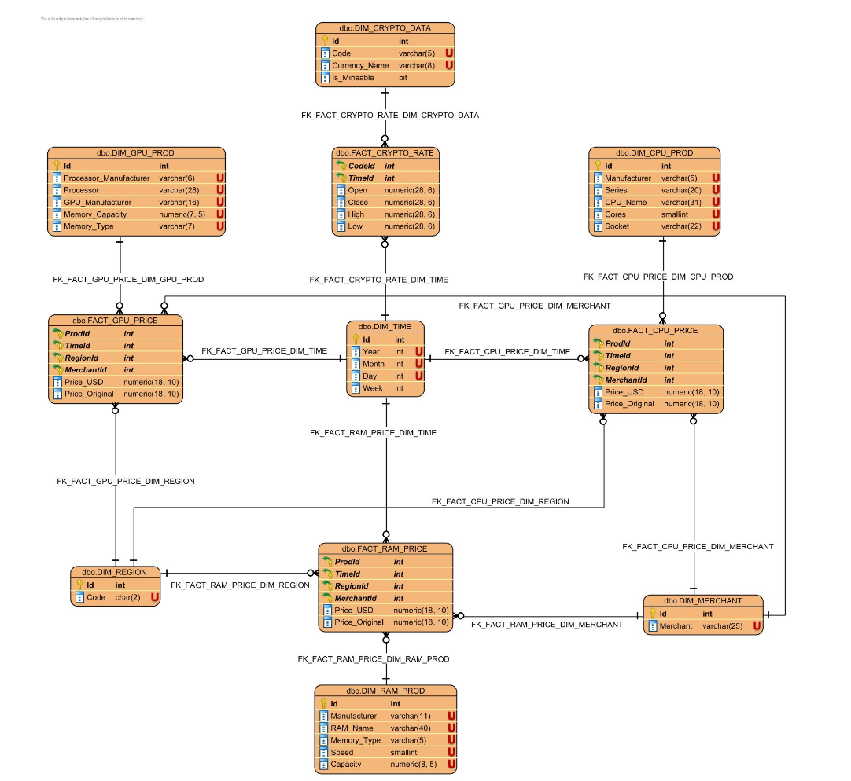
Because some of the data is irrelevant to the research, I have decided not to use the DIM_MERCHANT and DIM_REGION databases.

To make distribution of data over time I have decided to introduce 2 new ways of classifying time. The first one is RealTimeId which consists of dates starting from value 0 until the last value of 1958, the second method is TimeIdByMonth which distributes data over months, starting from value 0 until value 61.
TIME_ID
Value | Description
Id | Year * 1000 + Month * 100 + Day
Year | Year
Month | Month in a year
Day | Day in the month
Week | Week in the year
DIM_CRYPTO_DATA
Value | Description
Id | The ID of the Cryptocurrencies
Code | The Code of the Cryptocurrencies (e.g., BTH for Bitcoin)
Currency_Name | Name of the Cryptocurrencies
Is_Mineable | Is the cryptocurrency mineable? (0 – No, 1 – Yes)
FACT_CRYPTO_DATA
Value | Description
CodeId | Id from DIM_CRYPTO_DATA
TimeId | Id from DIM_TIME
Open | Open price in USA
Close | Close price in USA
High | High price in USA
Low | Low price in USA
DIM_RAM_PROD
Id | Id of the RAM Products
Manufacturer | Manufacturer of the product
RAM_Name | Name of the RAM
Memory_Type | Type of memory in the RAM product
Speed | Speed of the RAM product
Capacity | Capacity of the RAM product
FACT_RAM_PRICE
ProdId | Id from DIM_RAM_PROD
TimeId | Id from DIM_TIME
RegionId | Id from DIM_REGION
MerchantId | Id from DIM_MERCHANT
Price_USD | Price in the USA
Price_Original | Original Price in the USA
DIM_CPU_PROD
Id | Id of the CPU Products
Manufacturer | Manufacturer of the product
Series | Name of the Series
Cores | Number of Cores in product
Socket | Type of socket
FACT_CPU_PRICE
ProdId | Id from DIM_CPU_PROD
TimeId | Id from DIM_TIME
RegionId | Id from DIM_REGION
MerchantId | Id from DIM_MERCHANT
Price_USD | Price in the USA
Price_Original | Original Price in the USA
DIM_GPU_PROD
Id | Id of the CPU Products
Proccesor_Manufacturer | Manufacturer of the processor
Processor | Name of the processor
GPU_Manufacturer | Manufacturer of the GPU
Memory_Capacity | Capacity of the memory in the product
Memory_Type | Type of memory in the product
FACT_GPU_PRICE
ProdId | Id from DIM_GPU_PROD
TimeId | Id from DIM_TIME
RegionId | Id from DIM_REGION
MerchantId | Id from DIM_MERCHANT
Price_USD | Price in the USA
Price_Original | Original Price in the USA
Chapter 3: Research Methods
Data Manipulation:
Firstly, removing columns in DIM_TIME and adding other columns which are gonna be used in the work:
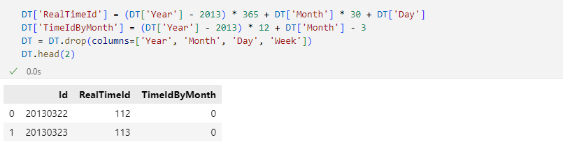
Secondly, combining multiple databases to work on them precisely. The combined databases became 4 dataframes, each consisting of values for Cryptocurrencies, CPU’s, GPU’s and RAM’s each.
Combined Crypto:
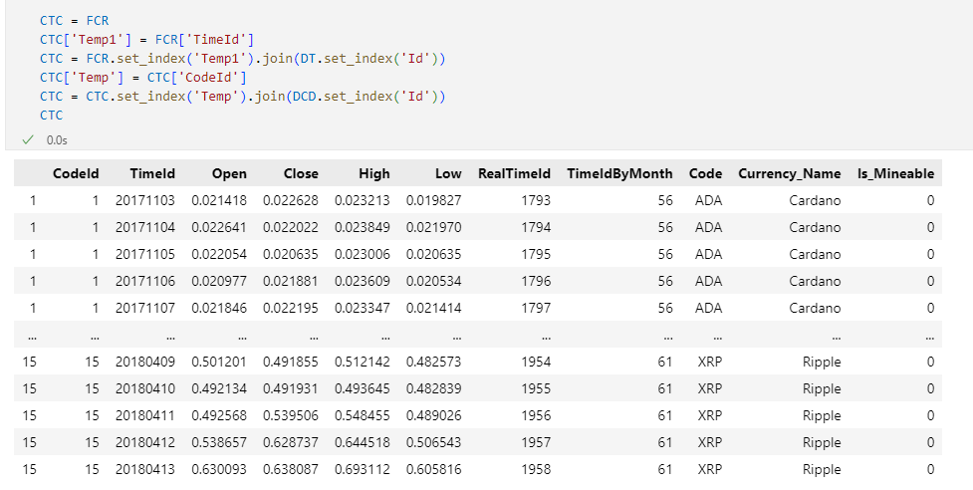
Combined RAM:
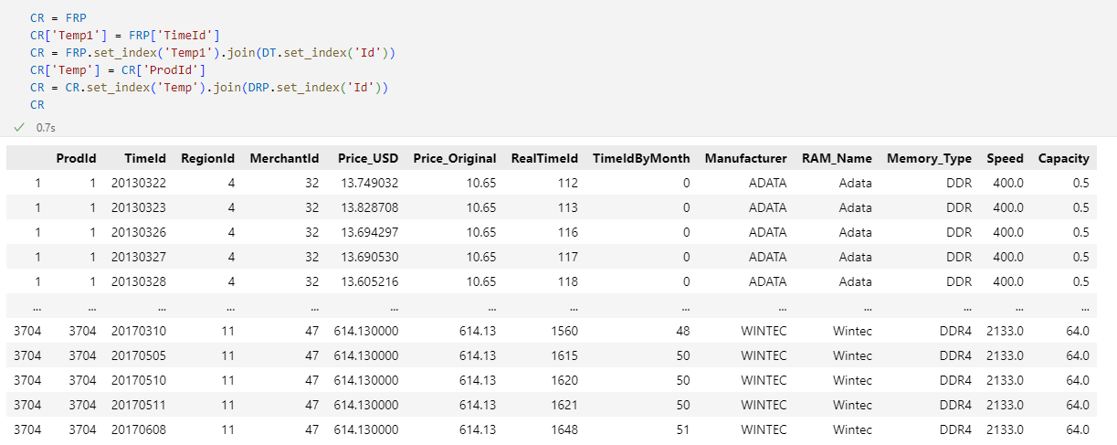
Combined CPU:
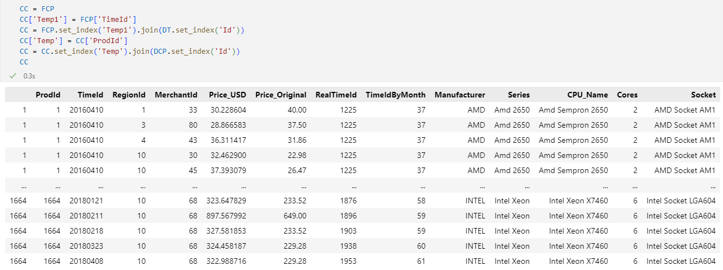
Combined GPU:
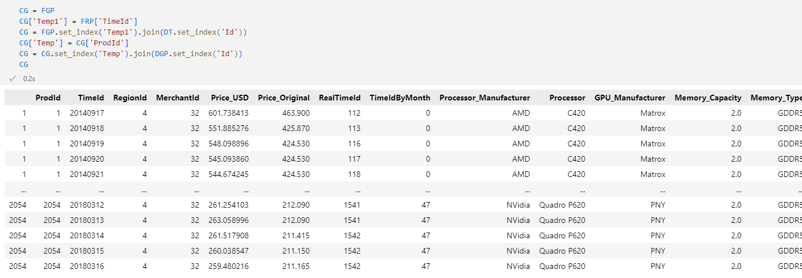
Because there were too many GPU_Manufacturer names I decided to split them up to 2 different dataframes:
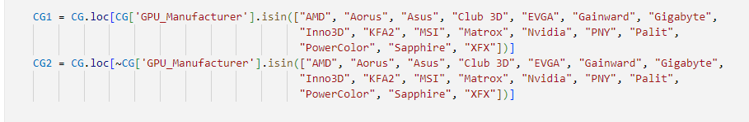
The First Assumption:
To confirm my first assumption, I need to compare between rises in cryptocurrencies values and other products values. I have decided to look at the Close values as I found it more reliable than Open, High and Low due to quick changes in cryptocurrencies values. Additionally, because of the massive amounts of products listed I have decided to use only TimeIdByMonth for the products.
Cryptocurrencies values between 2013 and 2018 precisely:
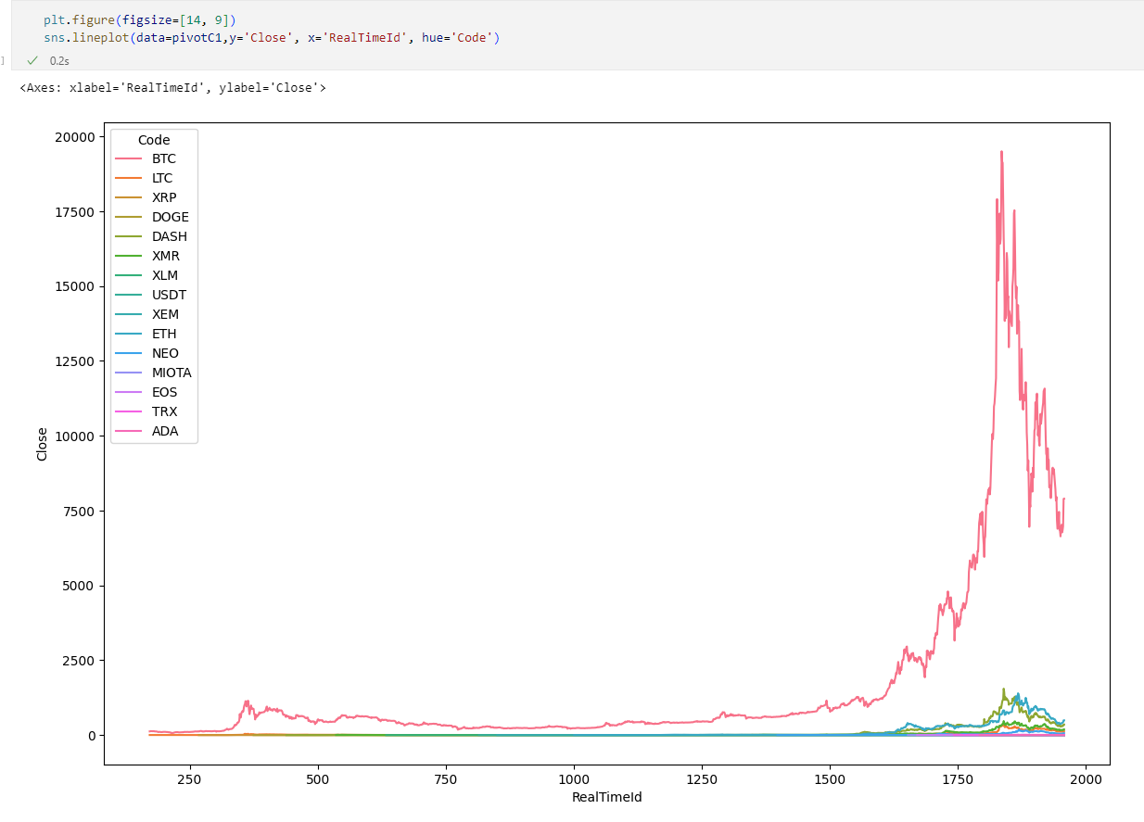
Cryptocurrencies values between 2013 and 2018 by monthly change:
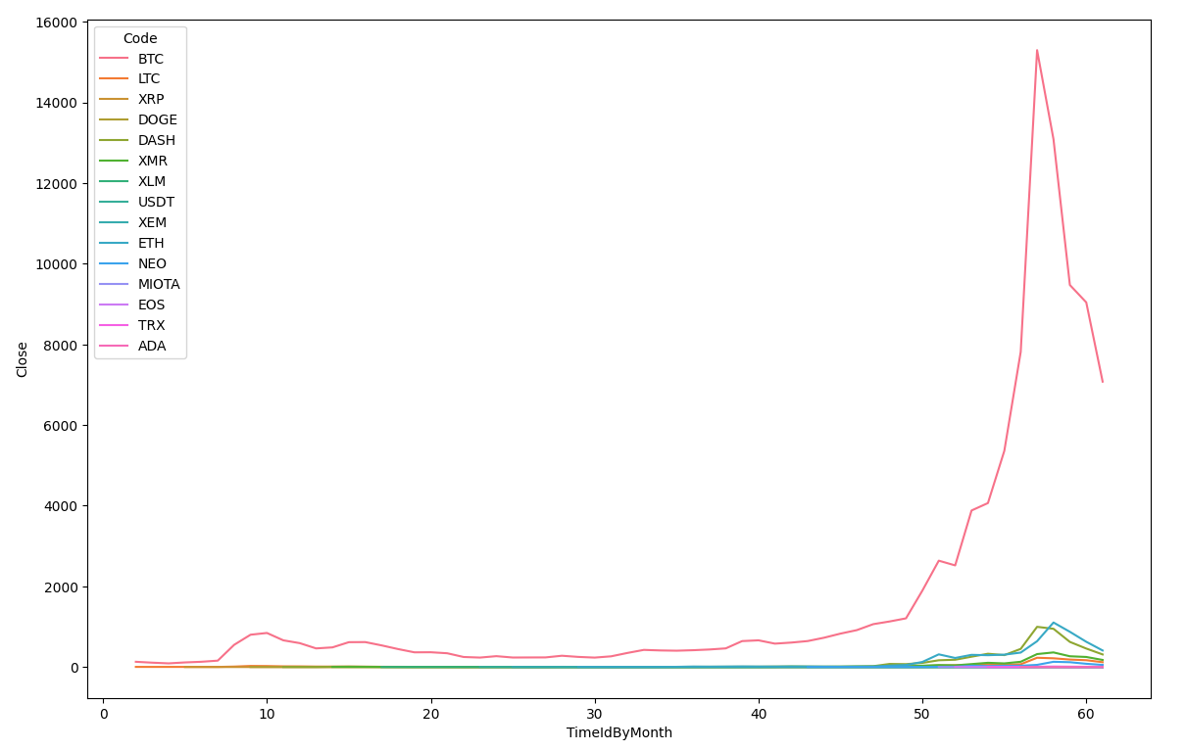
In both versions we can see big changes in the months 10 – 20, 30 – 40, 40 – 50 and a massive spike of increase in the months 50 – 61.
I used a pivot table for the RAM values that are grouped by TimeIdByMonth and Manufacturer:
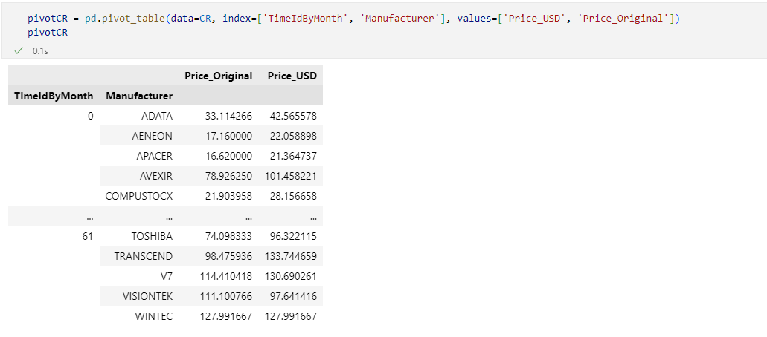
And the plot for it:
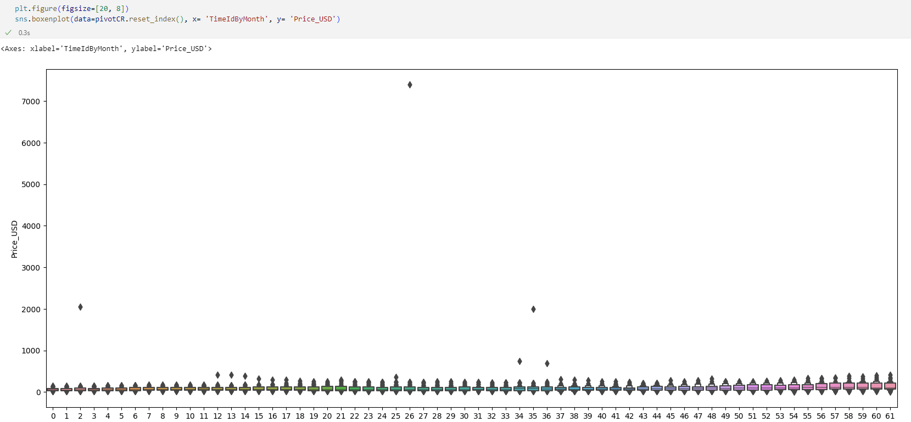
In this graph we can see a small increase in values between the months 15 – 25, 30 – 40, 40 – 50 and a bigger increase between the months 50 – 61. This shows there is in fact a connection between RAM prices and cryptocurrency prices.
I used a pivot table for the CPU values that are grouped by TimeIdByMonth and Manufacturer:
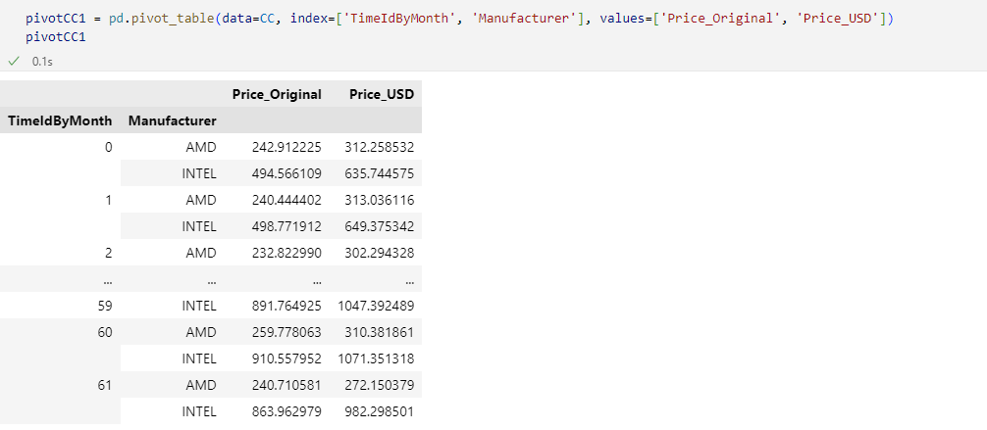
And the plot for it:
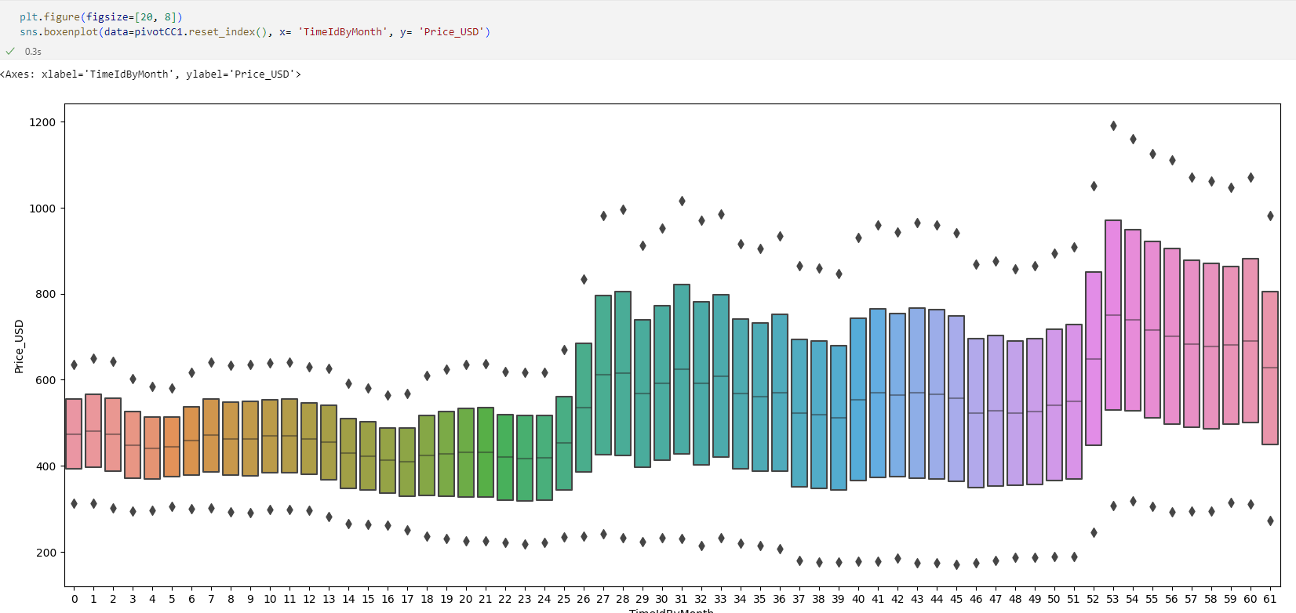
In this Graph we can see massive spikes of increases in between the months 24 – 34 and 50 – 61, and in addition we can see smaller spikes between the months 6 – 12, 17 – 22 and 40 – 45. Strongly Conforming the connection between cryptocurrency prices and CPU Prices.
I used a pivot table for the GPU values that are grouped by TimeIdByMonth and Manufacturer:
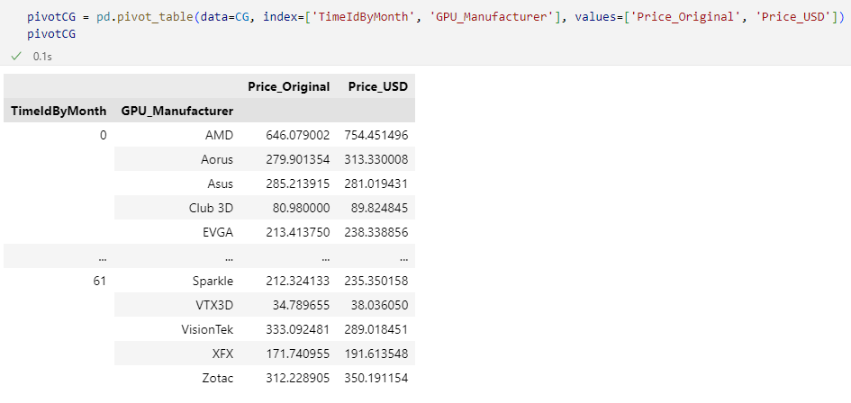
And the plot for it:
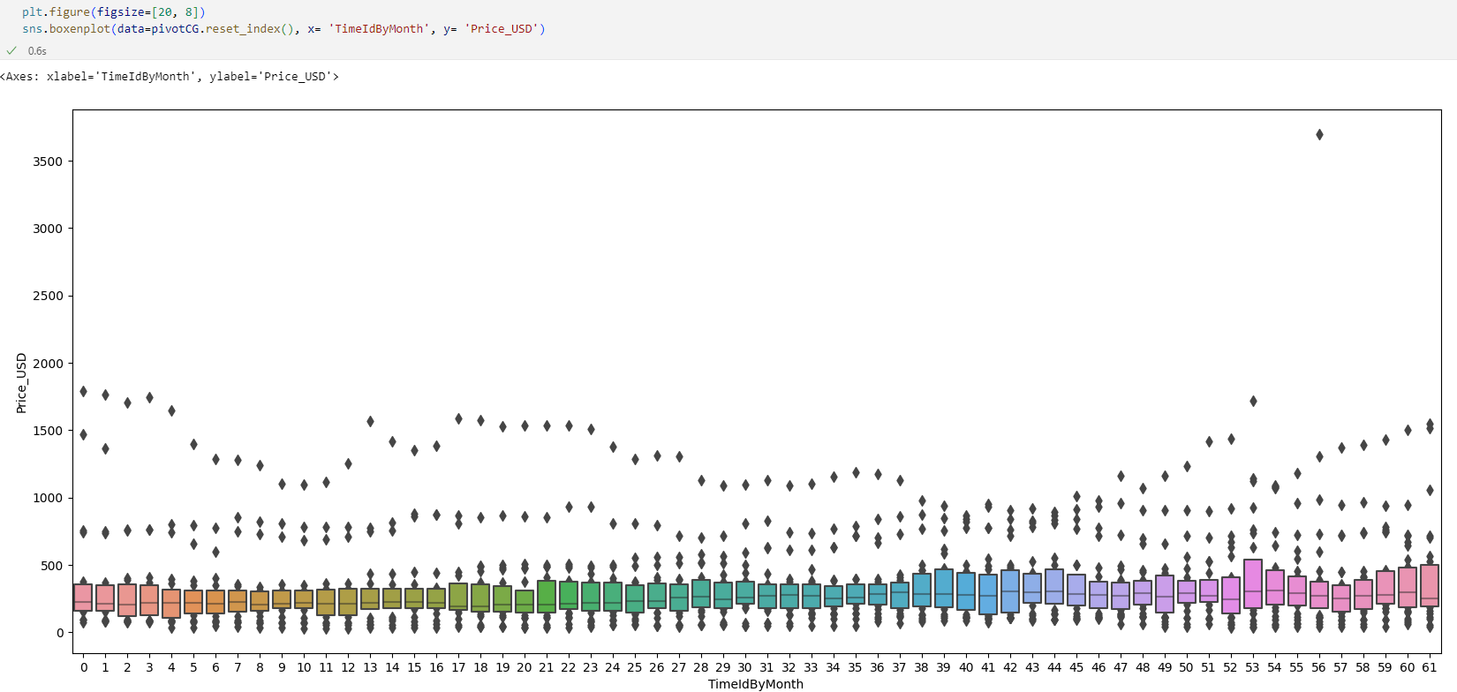
We can see some major spikes between 37 – 46, 49 – 56, 56 – 61 which indicates a small yet existing connection between GPU Prices and Cryptocurrencies.

The Second Assumption:
To confirm the next assumption, I checked every special characteristic available and put them into a pivot table and then transformed it into a plot.
Firstly, I created pivot table for the RAM based on the characteristics: Speed, Memory_Type and Capacity.
The pivot table for Speed is:
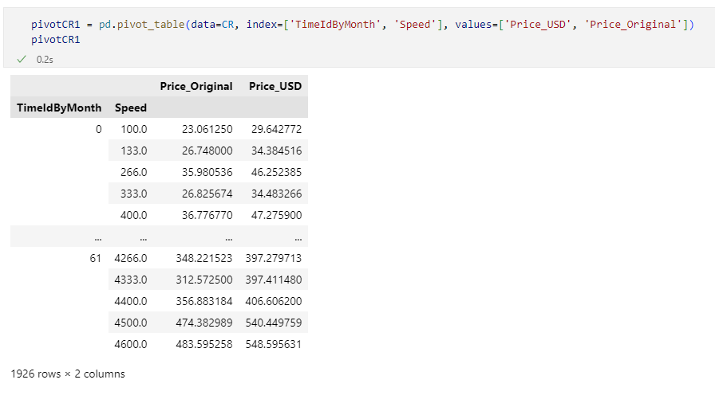
The pivot table for Memory_Type is:
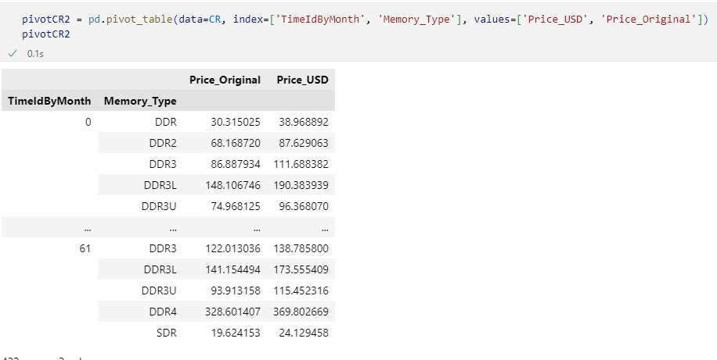
The pivot table for Capacity is:
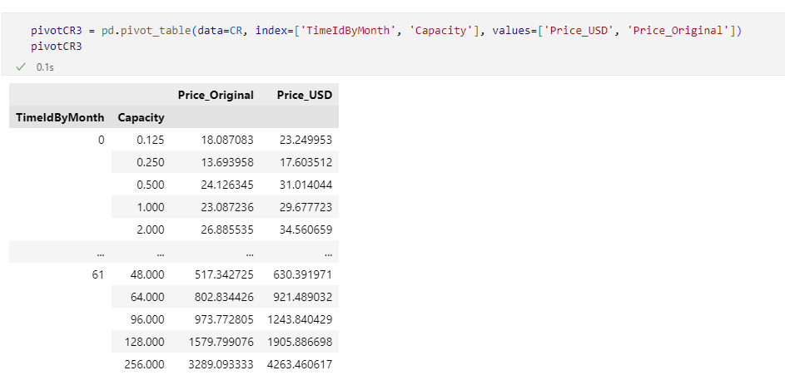
For each pivot table I created 2 graphs. The first graph shows the value of each type of the selected characteristics throughout the span of 2013 – 2018, whilst the second graph shows a more general look on the same values.
The first graphs are for Speed:
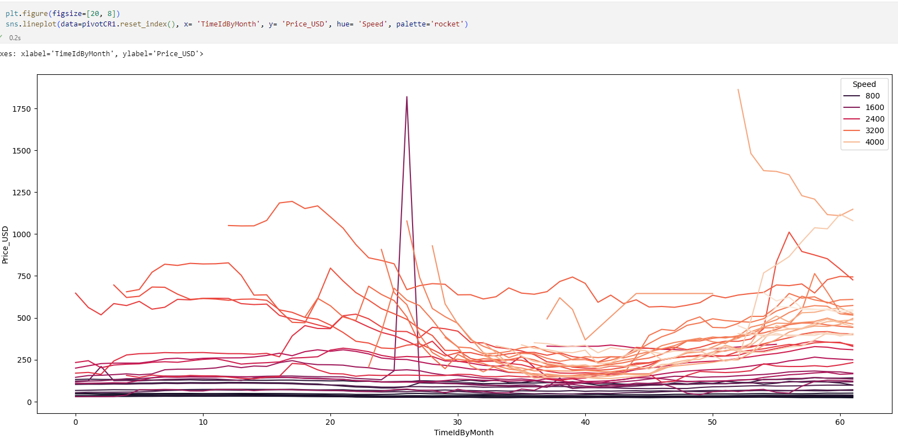
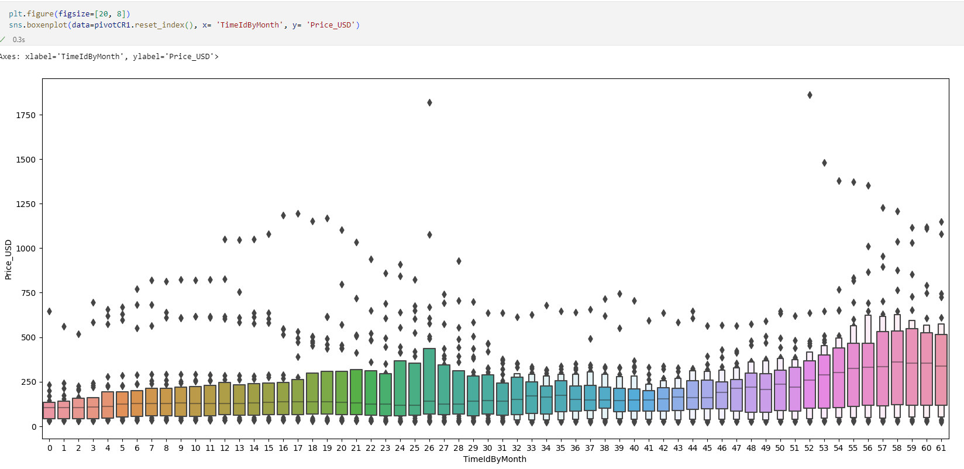The next graphs are for Memory_Type:
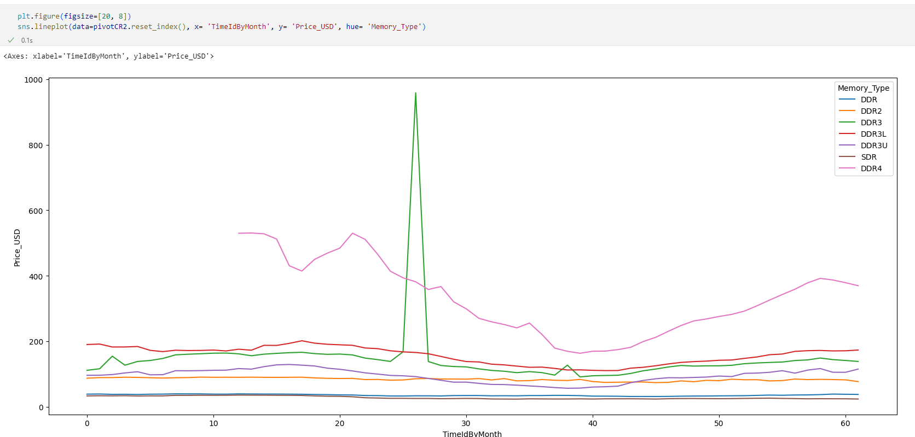
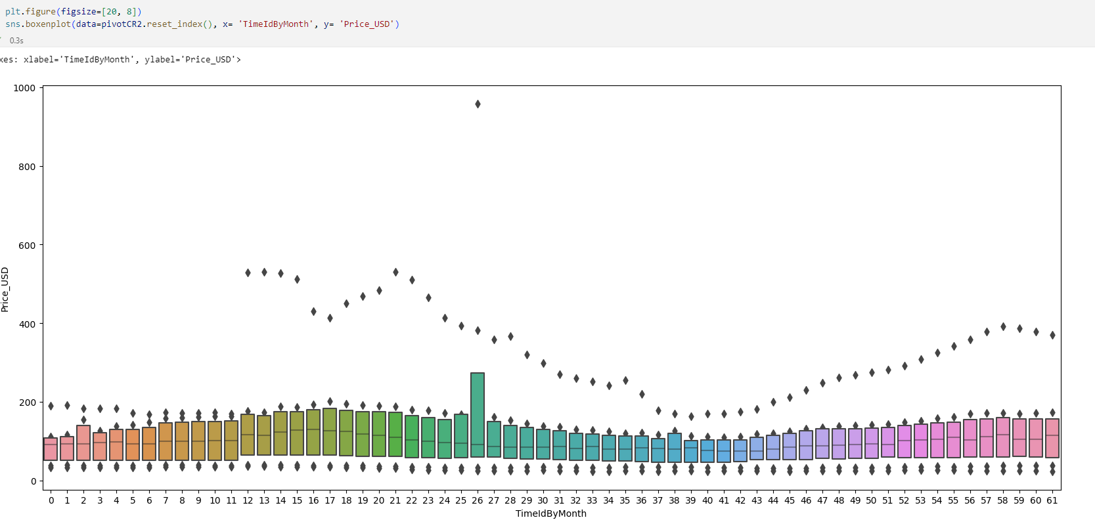The last two graph are for Capacity:
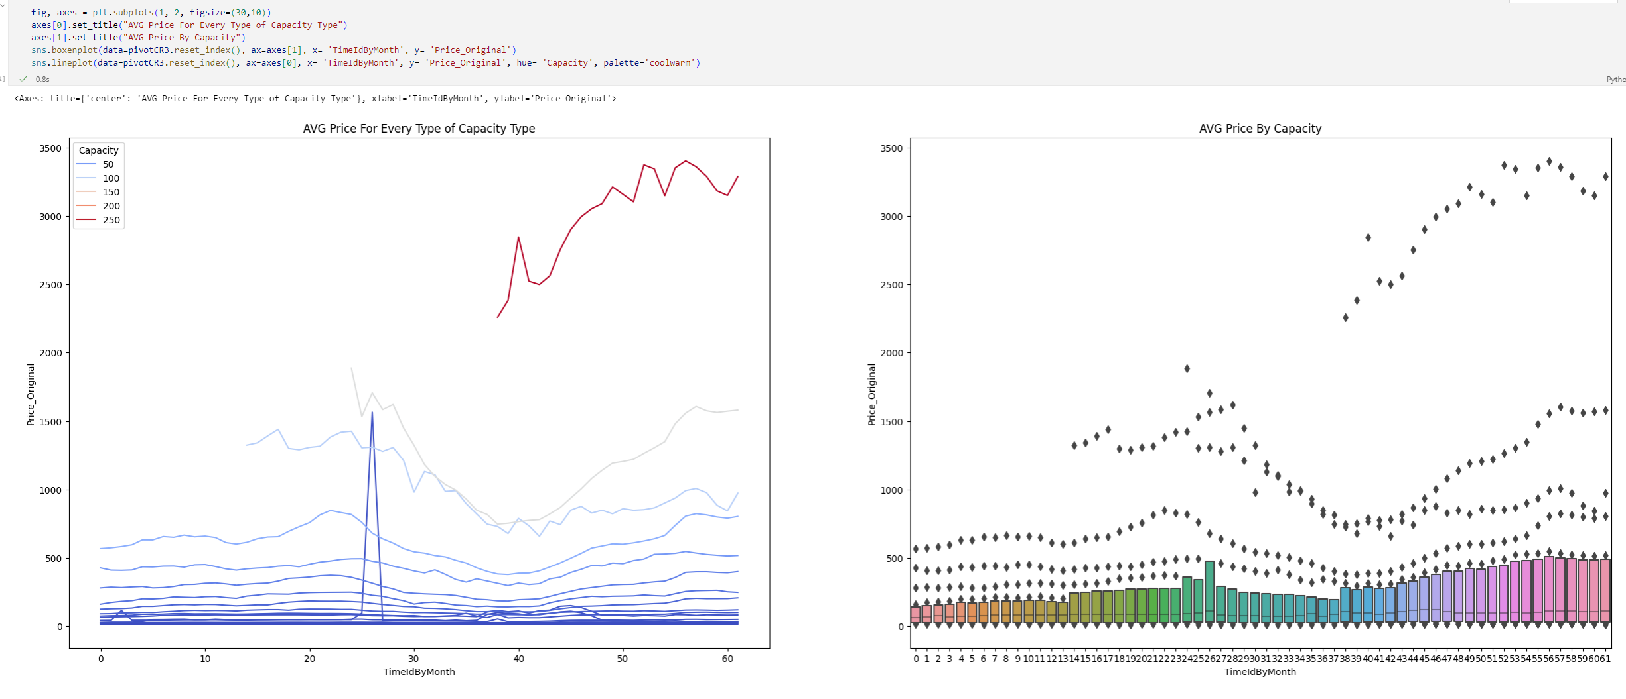

Secondly, I created pivot tables for the CPU products based on the only specific characteristic – Cores.
The pivot table for Cores is:
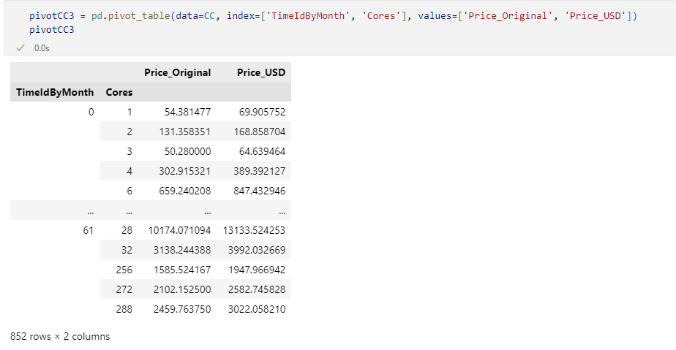
Just like the RAM I created 2 graphs for the pivot table and compared it to the Cryptocurrency graph.
The graphs for Cores are:
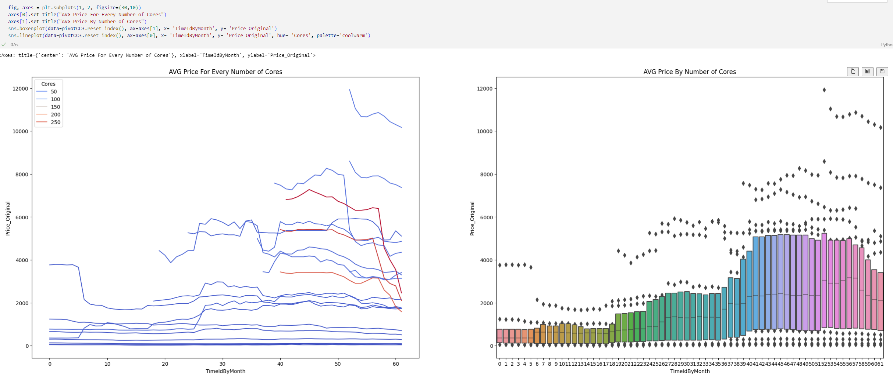

Lastly, I created pivot tables for the GPU products based on the characteristics: Processor, Memory_Capacity and Memory_Type.
The pivot table for the Processor is:
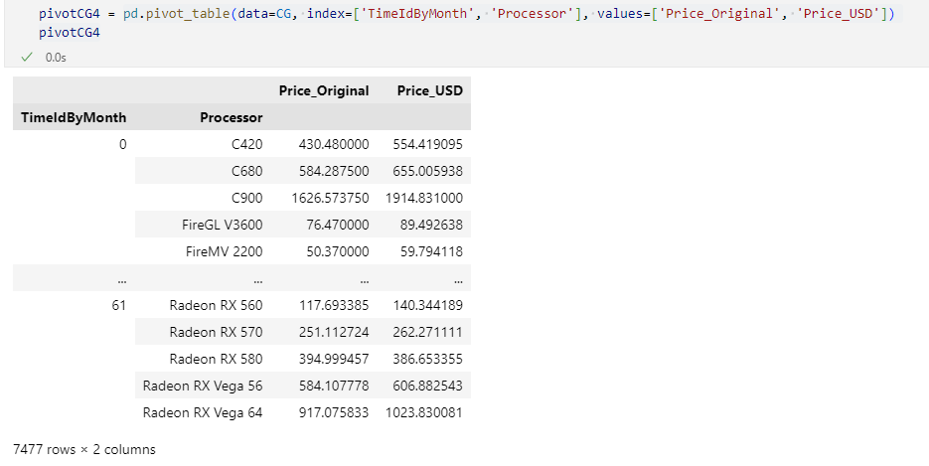
The pivot table for the Memory_Capacity:
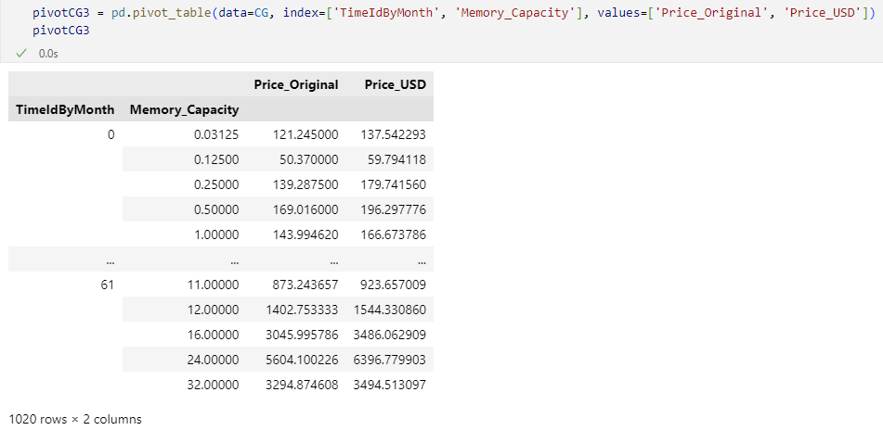

The pivot table for the Memory_Type:
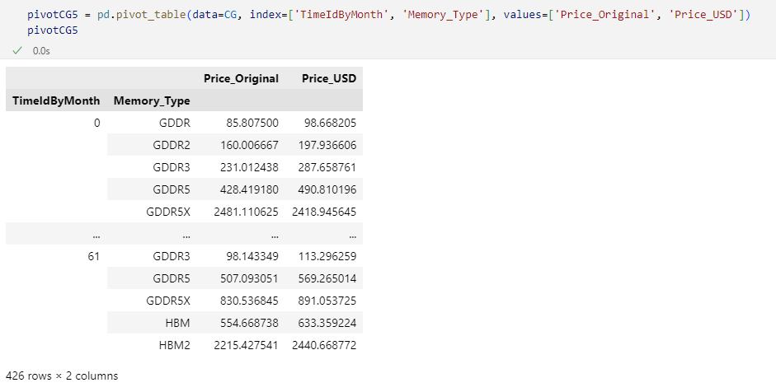
Just like the previous products I created 2 graphs for the pivot table and compared it to the Cryptocurrency graph.
The graphs of the Processor are:
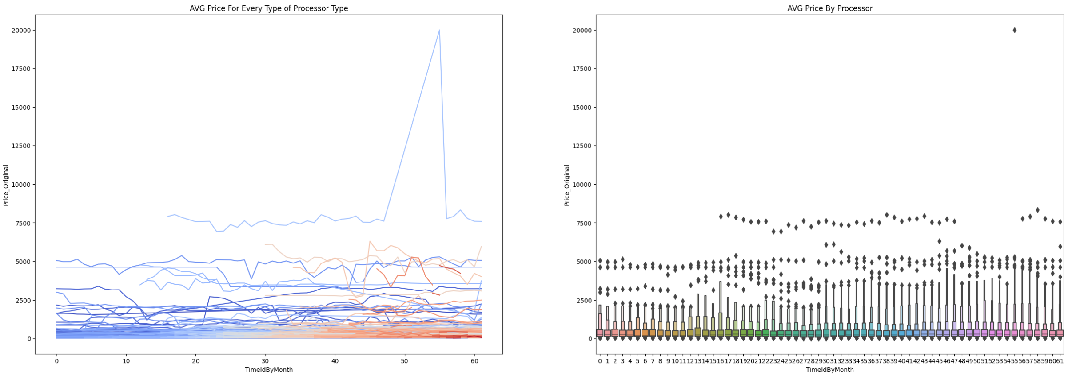

The graphs for the Memory_Capacity are:
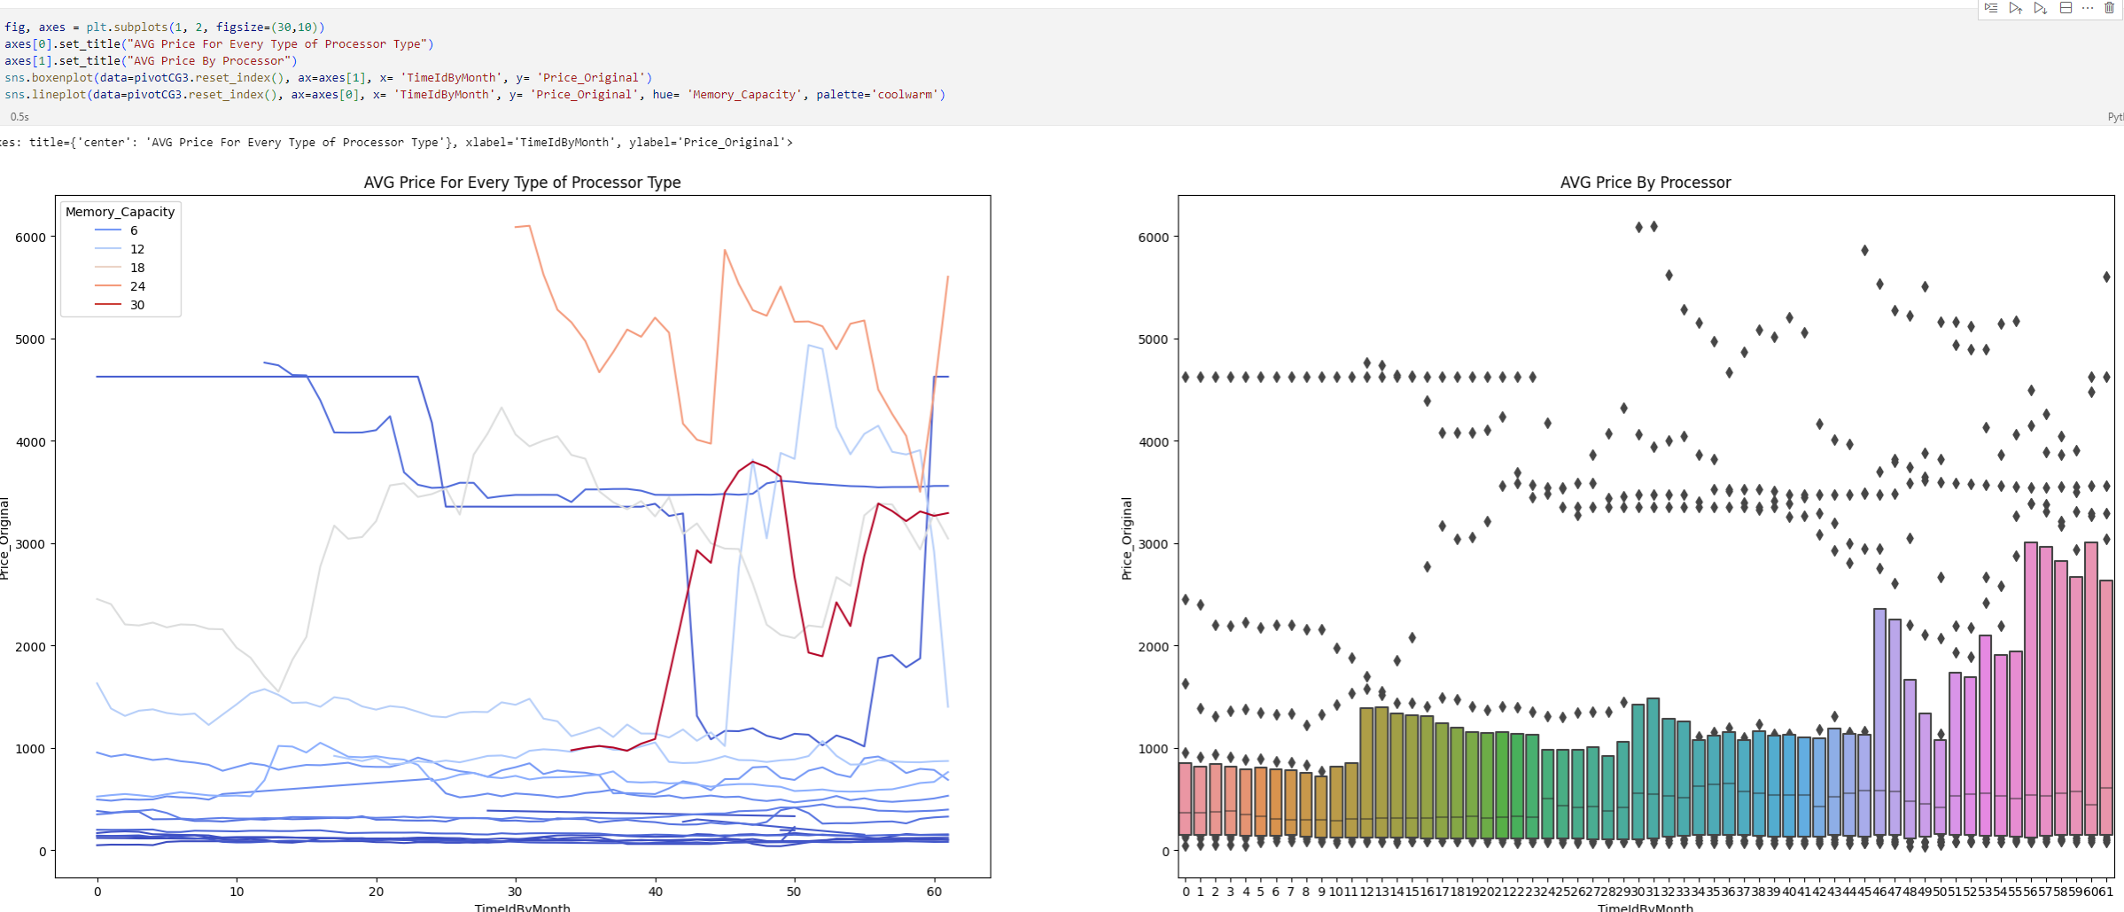
The graphs for the Memory_Type are:
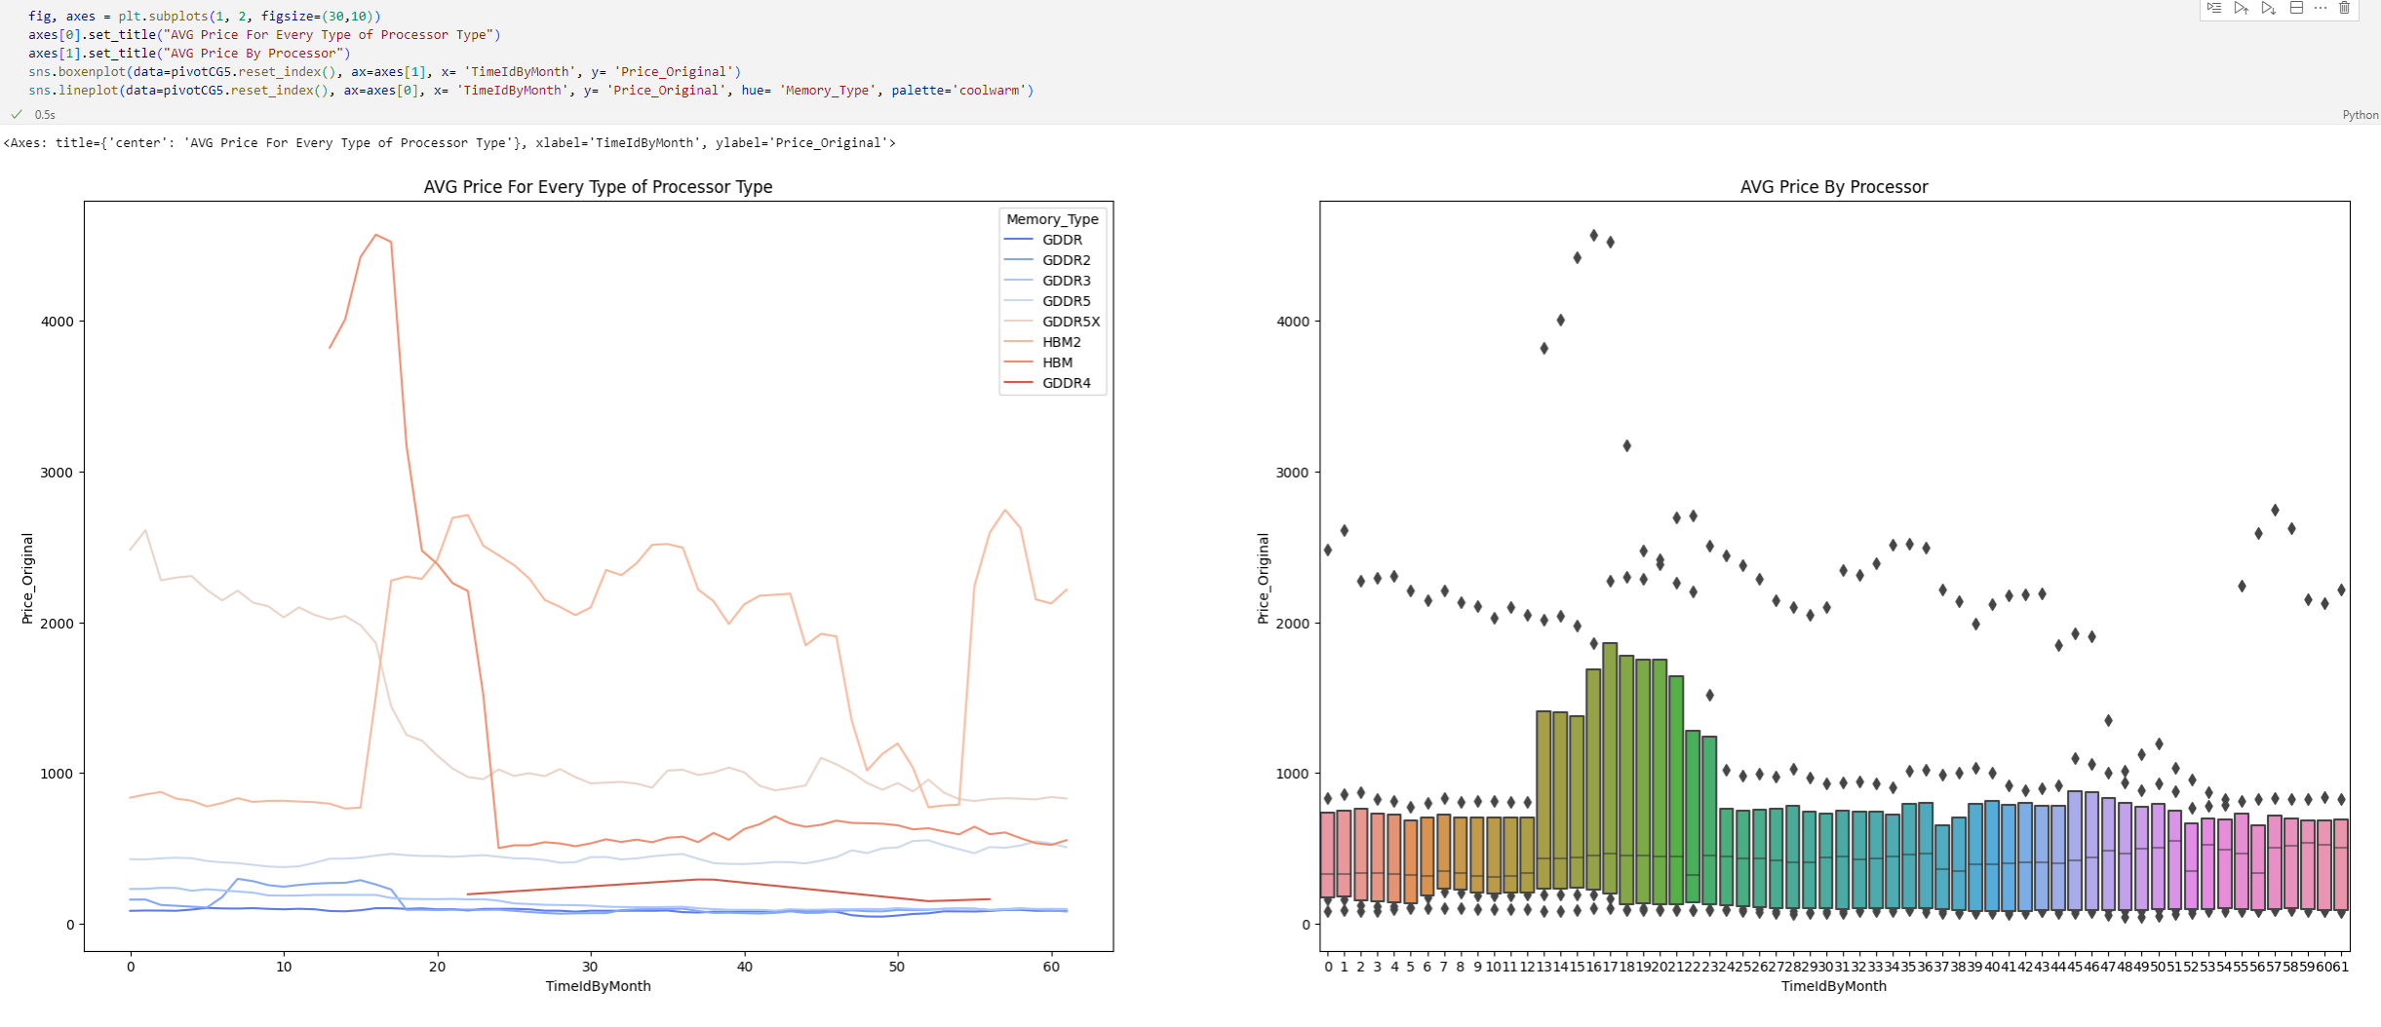

Chapter 4: Summary and Conclusions
To conclude the data, we must look at the cryptocurrency graphs and each one of the specific characteristics to analyze the connection between the 2 of them.
Firstly, the cryptocurrency graphs:

Secondly each one of the specific characteristics:
RAM:
The first graphs are for Speed:


The 2 graphs show a major spike between the months 18 – 30 and 45 – 61. In addition to that we can see a general increase in all prices after the 10th until the 30th month and a much more noticeable rise after the 40th month. This confirms a connection between the rise of cryptocurrencies and RAM products due to Speed.

The next graphs are for Memory_Type:


The 2 graphs show a major spike of increase between 24th and the 27th month and smaller increases between 2 – 17 and a general increase of all prices after the 44th month. Upon checking with the cryptocurrencies graph we can see no major connection between the two variables therefore we cannot establish a connection between the Memory_Type and Cryptocurrency prices rise.

The last two graph are for Capacity:

We can see that from the graphs there exists a huge increase spike between the months 24 – 27 and 48 – 61. To add to that we can see a clear increase in all prices upon entering the 38th month. We can see a clear connection between cryptocurrency prices and Capacity especially because of the massively high value of the higher Capacity RAM.

CPU:
The graphs for Cores are:

We can see a massive spike increase of price between the month 37 – 56 and the massive fall after it, which matches up with the increase of cryptocurrency prices along with their fall perfectly and confirms a connection between them.

GPU:
Just like the previous products I created 2 graphs for the pivot table and compared it to the Cryptocurrency graph.
The graphs of the Processor are:

From the graphs we can see a huge spike increase in the months 50 – 61 with multiple GPU prices flying high exactly where there is a huge increase in cryptocurrency prices and huge decrease at the same places as the fall after the huge spike. This shows a big connection between the Processor and the cryptocurrencies.

The graphs for the Memory_Capacity are:

As we can see from the graphs there are many different spikes of increase and major increase of prices after the 50th month but the connection is unlikely because there is an increase during the cryptocurrency’s prices fall but not before it, therefore we can say there is no connection between Memory_Capacity and cryptocurrencies prices.
The graphs for the Memory_Type are:

The graphs show an increase in prices especially between 13 – 23, but there is only one type of Memory_Type that shows a connection but all the other Memory_Type are just not connected at all so we can conclude that no connection exists.

Conclusion:
We can see that there exists a connection between multiple PC parts and their specific components and the rise of cryptocurrencies, but some do not have any connection to it.

Chapter 5: Reflection
I have never done anything like this work before and I have enjoyed it thoroughly by learning new things mostly by myself. There were some low points at the work, but I found the motivation to move forward simply by discussing it with my friends and finding a way forward. In addition to that the whole subject interests me so I found it easier to move forward and enjoy the work.

